Goals:

-Review any topics

(e.g. Quiz 2)

-Lab 2

New focus

|  |  |  |  |  |  |  |  |
| --- | --- | --- | --- | --- | --- | --- | --- |
| 7 | 6 | 5 | 4 | 3 | 2 | 1 | 0 |

n-bits

Bit(n-1) msb

(Last week’s explorations on hold for now) i.e timing memory analysis tools

Exploration of types of memory

-Global variables (Stack)

-registers

-symbolic constants (no memory)

Programmers cannot access this – cache

Secondary memory (must be put in RAM first)

Lab

sudo apt-cache search curl | less

| less

p for previous

n for next

[] texfot.pl

sudo chmod 755 texfot.pl

755 -> 111 101 101 -> drwxr-xr-x

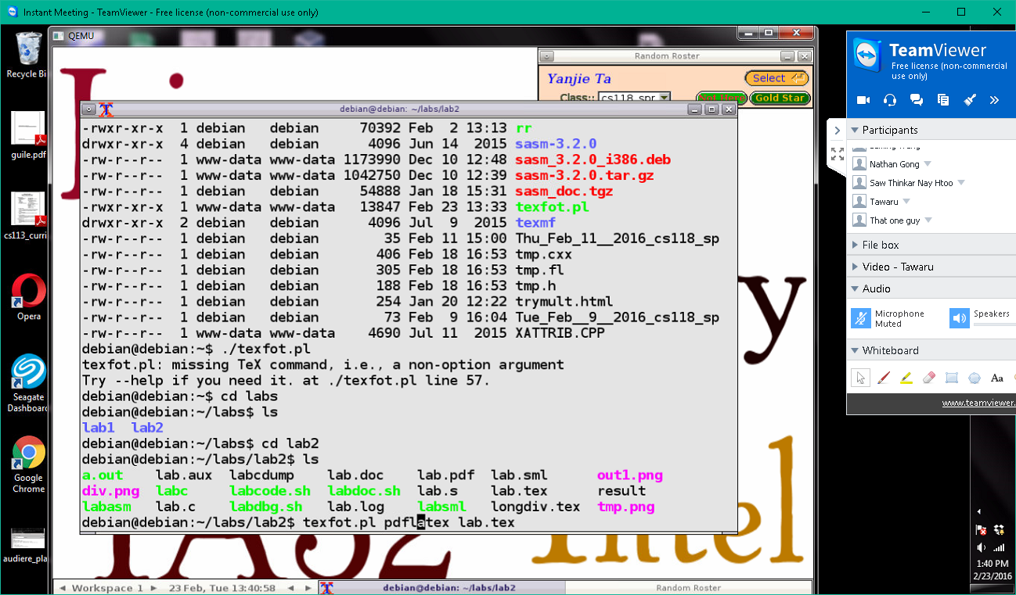

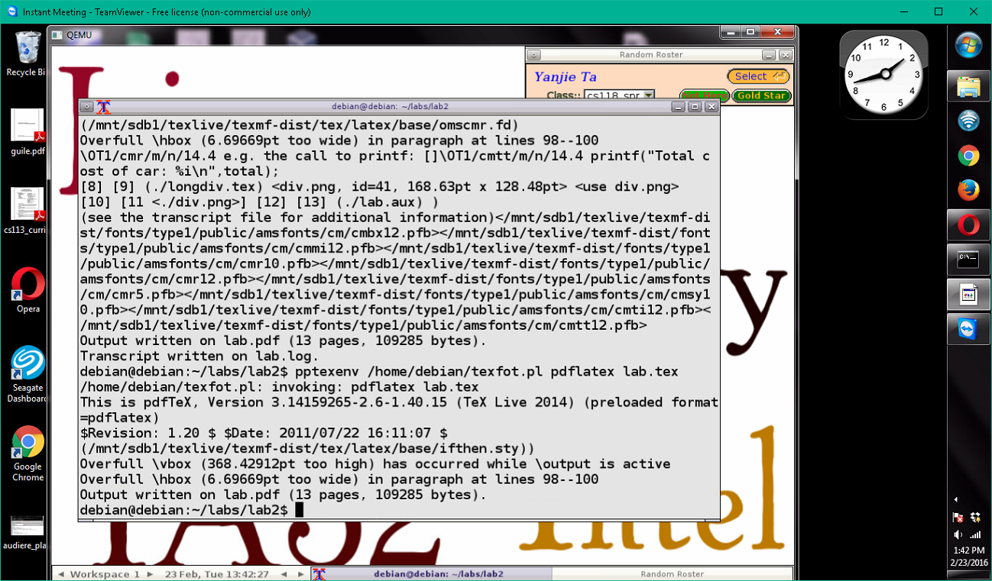

int a = 1;

printf(“%x”,a);

|  |  |  |  |
| --- | --- | --- | --- |
| 00 | 00 | 00 | 01 |

|  |
| --- |
| 01 low |
| 00 |
| 00 |
| 00 high |

in gdb

01,(low) 00 00 00,(high)

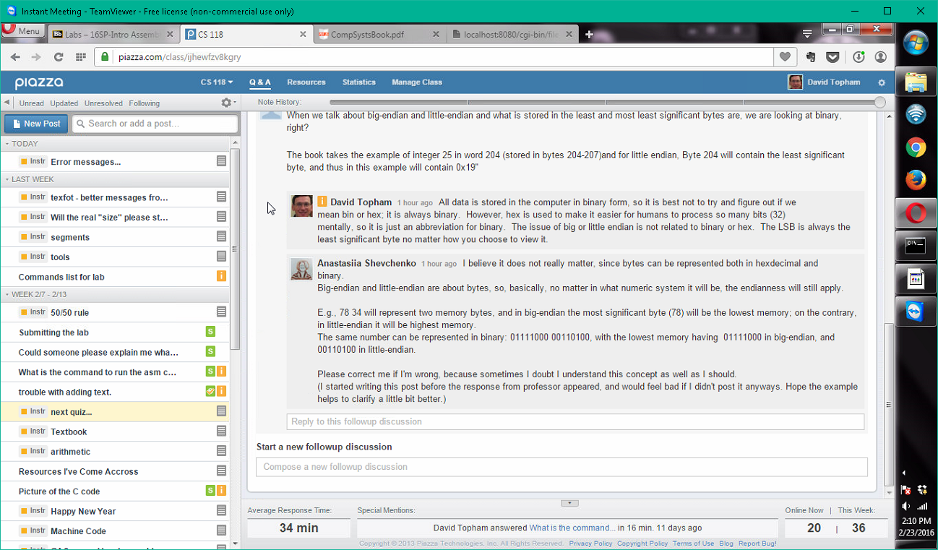

CISC IA 32 intel (complex)( ea instruction is not a fixed size)

RISC (reduced ea instruction is fixed size) (e.g. 4 bytes = word size)

Does big endian issue affect instructions?

call

push

mov

add

mul

div

pop

compare risc and cisc

<http://cs.stanford.edu/people/eroberts/courses/soco/projects/risc/risccisc/>

The flag bits allow programmer to check for problems with a computation (such as overflow)

IA 32

32 bits

cflags

IPE

Draw diagrams w/ Latex supported

